WILLINGTON HOUSING AUTHORITY
*** February 12, 2018 REGULAR MEETING CANCELED ***

The February 12, 2018 regular meeting of the Willington Housing Authority has been canceled due to lack of quorum.

Respectfully Submitted,
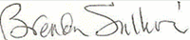

Recording Secretary

